Radioactivity
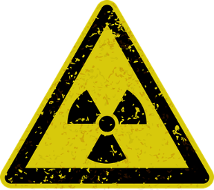

What is Radioactivity?
Radioactivity refers to the emission of mass and energy when an atom’s nucleus changes. These changes are the result of instability within the nucleus. In order to understand radioactivity, we need to step back and learn about atoms and isotopes.
Radioactivity is the emission of mass and energy from an atom.

What are Atoms and Isotopes?
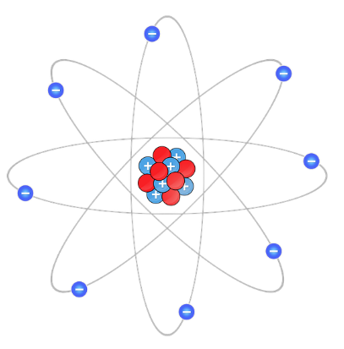
An atom is the smallest unit of an element (e.g. hydrogen, oxygen). Atoms are composed of a nucleus – the center of the atom, which contains neutrons and protons – and electrons that orbit the nucleus. Electrons are negatively charged particles, neutrons carry no charge, and protons are positively charged. Atoms are defined by their atomic number, which represents the number of protons in the nucleus. For example, at atom of carbon has 6 protons in its nucleus, and thus an atomic number of 6. The number of electrons determines whether an atom is neutral, positively charged, or negatively charged. An equal number of electrons and protons denotes a neutral atom. An atom with fewer electrons than protons is positively charged. Such an atom is an ion, called a cation. Conversely, an anion is a negatively charged ion, having more electrons than protons. Neutrons, on the other hand, affect the mass of an atom without affecting its chemical properties.
Atoms consist of protons and neutrons in a nucleus and electrons orbiting that nucleus.

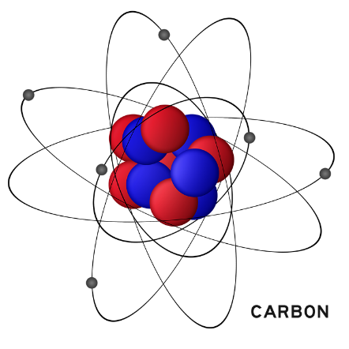
An isotope is a version of an element that differs from the base version in the number of neutrons in its nucleus. Thus, it has a different mass than the base version. There are several isotopes of each element. Let’s return to our carbon example. The base version of carbon is carbon-12. It has 6 protons and 6 neutrons. Carbon-14, on the other hand, has 6 protons and 8 neutrons. It is still carbon, because it has 6 protons, but its mass is greater than a regular carbon-12 atom. There are two most commonly discussed types of isotopes. The first are stable isotopes, which, as their name suggests are in a stable state and don’t easily change. Radioisotopes, on the other hand, are unstable. In order to become stable, they release particles, which in turn releases energy. This process is called radioactive decay, and is responsible for radioactivity. Radioisotopes can cycle through many different steps as they become stable. Along the way, they can become different isotopes of the same element, or become a different element altogether. The process of becoming a different element is called transmutation. Uranium-238, for example, reaches stability when it becomes lead. Before it reaches this point, however, it becomes a successive string of increasingly stable elements: thorium, radium, radon, polonium, and bismuth.
Base carbon, carbon-12, has 6 protons and 6 neutrons, while the isotope carbon-14 has 6 protons and 8 neutrons.

Types of Radioactivity
There are three common types of radioactivity: alpha, beta, and gamma.

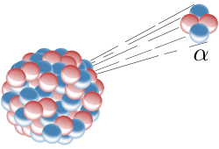
Alpha (α) decay involves the release of a particle consisting of two neutrons and two protons (a positively charged particle). This particle is called an alpha particle and is equivalent to a helium nucleus. Alpha decay results in the parent isotope becoming a different element as both its atomic number and mass decrease (the atomic number by two and its mass by four). Returning to our uranium example, uranium-238 undergoing alpha decay will become thorium-234. Alpha radiation can pass through only a few centimeters of air and cannot pass through a standard sheet of paper.
Alpha decay emits two neutrons and two protons.

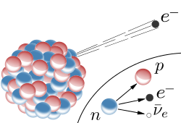
Beta decay is divided into beta-plus (β⁺) and beta-minus (β⁻) decay. In β⁺ decay, a proton becomes a neutron, a positron, and a neutrino. A positron is an electron with a positive charge, also known as an antielectron. (Antiparticles are the opposite counterparts of particles, meaning they have the same mass as the particle with an opposite electric and/or magnetic charge.) A neutrino is an extremely tiny particle within an atom that has no electric charge and interacts weakly with other particles. When protons become these three particles, the positron and neutrino are emitted, and the isotope has lost a proton, which changes it to a different element. In β⁻ decay, a neutron turns into a proton, an electron, and an antineutrino. An antineutrino is simply the antiparticle of a neutrino. Because of their lack of charge and weak interactions, it is thought that they may, in fact, be the same. Like the result of β⁺ decay, the electron and antineutrino are released, the isotope has an additional proton, and it has become a different element. In both types of beta decay, the total number of particles doesn’t change, just the type of particles present. Beta radiation can pass through aluminum of a few millimeters thickness.
In beta-minus decay, an electron is emitted.

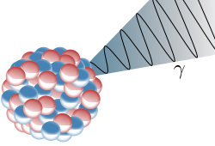
Finally, in gamma (γ) decay, a nucleus with excess energy releases a photon (unit) of energy called a gamma particle. In this way, the nucleus reaches a lower energy state. Most isotopes that undergo gamma decay have been left in a high-energy state due to alpha or beta decay. They continue emitting gamma rays until they attain a low energy (or ground) state. One of two other processes occurs during gamma decay. One, internal conversion, involves the extra energy being transferred to an electron, pushing that electron out of its orbit and away from the atom. The second, internal pair production, is characterized by excess energy becoming an electron and a positron, which are both released from the atom. Gamma radiation can pass through lead of several centimeters thickness.
In gamma decay, a gamma ray is emitted.
When comparing the three types of radiation it’s difficult to say which is the most harmful to living things. Alpha radiation is the most easily absorbed by cells but can’t pass through the skin. Beta and gamma radiation aren’t absorbed as easily by cells but can easily penetrate clothes, skin, and bodily tissues.

Half-lives
Radioactive decay can take anywhere from milliseconds to billions of years, depending on the radioisotope. It is measured in half-lives, or the amount of time it takes, on average, for half of the material to decay. This measurement applies no matter how much there is. Thus, in one half-life, half of the original amount of radioisotope will remain, and in a second half-life, half of that (or one quarter the original amount) will be left. Our old friend uranium-238 has a half-life of about four billion years, while iodine-131 has a half-life of only eight days. This means that if you have 4 kg of uranium-238 lying around, in four billion years, half will be gone. Comparatively, half of your iodine-131 will be gone in only 8 days.

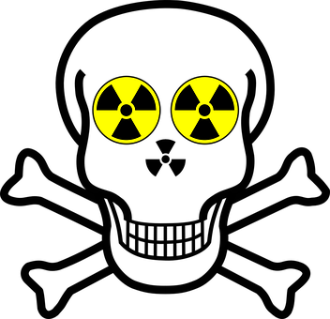
Is Radioactivity Dangerous?
Radiation exists naturally everywhere in the world, in gamma rays from space, the decay of radon gas in the atmosphere, uranium in the ground, and many other sources, some of which are man-made. Our intake of this radioactivity is measured in Sieverts (energy per kilogram multiplied by a factor that accounts for the tissue absorbing the radioactivity and the type of radiation). In the US, this background radiation is about 6.2 millisieverts (mSv) per person per year, while in the UK, it is between 2 and 2.5 mSv per person per year. In northern Iran, the background radiation reaches 50 mSv per person per year. Dental x-rays expose you to less than 1 mSv, while a full-body CT scan results in about 10 mSv.
High doses of radiation over short periods of time can be very dangerous.
At high doses, radiation can be dangerous for human health. The main effect of radiation is cell death, which can be severe depending on how much radiation is experienced and how long the exposure lasts. Emergency workers are allowed to be exposed to 100 mSv when protecting property and 250 mSv when saving lives. The symptoms of such exposure include nausea and organ damage. If exposed to 3 Sv over the course of one day, these symptoms worsen and are accompanied by the risk of infection due to a reduction in white blood cells. If treated, people under this level of exposure are likely, though not guaranteed, to survive. Above this level, exposure results in additional symptoms, including skin peeling off, hemorrhaging, and sterility. Above 3.5 Sv, anyone who doesn’t receive treatment will die. Above 6 Sv, and even treatment is unlikely to prevent death.
Increasing distance from a radiation source results in decreasing dosage and, consequently, effects. Someone twice as far away from a source as someone else will receive a quarter of the radiation as the closer individual.
High doses of beta particles can build up in tissues and lead to cancer. However, the cancer risk from normal radiation is very low. The risk of cancer from routine medical scans is only 1 in 20,000 per mSv. The absorption of 1 Sv of radiation over a long period of time leads to about a 5% chance of developing cancer.
Radioactivity, like everything else, is dangerous if you receive too much.

Reading Comprehension Questions
- What is radioactivity?

- What is an atom?

- What are the particles in an atom? What are their charges?

- How are atoms defined?

- What is a cation? What is an anion?

- What is an isotope?

- What are the two main types of isotopes?

- What is transmutation?

- What are the three types of radioactivity? What is released by each?

- What is a half-life? What is the half-life of uranium-238?

- What is radiation measured in? At what level of radiation is treatment ineffective?

Extension Questions
- Develop an infographic describing the three types of radioactivity. Include diagrams of the processes of each. Check out canva.com for templates.

References
“Antineutrino.” (n.d.) Nuclear Power. Retrieved October 10, 2017, from http://www.nuclear-power.net/nuclear-power/reactor-physics/atomic-nuclear-physics/fundamental-particles/antineutrino/.
Bartels, Meghan. (2017, Oct. 4). “Radiation from Fukushima nuclear disaster discovered in sand and groundwater 60 miles away.” Newsweek. Retrieved October 10, 2017, from http://www.newsweek.com/fukushima-radioactive-cesium-ocean-677449.
“Beta Decay.” (2000). Guide to the Nuclear Wallchart. Retrieved October 10, 2017, from http://www2.lbl.gov/abc/wallchart/chapters/03/2.html.
Gagnon, S. (n.d.) “Beta Decay.” Glossary. Retrieved October 10, 2017, from https://education.jlab.org/glossary/betadecay.html.
Hamers, L. (2017, Oct. 2). “Radioactive material from Fukushima disaster turns up in a surprising place.” ScienceNews. Retrieved October 10, 2017, from https://www.sciencenews.org/article/radioactive-cesium-fukushima-groundwater.
Hvistendahl, M. (2007). “Coal Ash Is More Radioactive Than Nuclear Waste.” Scientific American. Retrieved October 10, 2017, from https://www.scientificamerican.com/article/coal-ash-is-more-radioactive-than-nuclear-waste/.
McGrayne, S.B., Trefil, J., Bertsch, G.F., and Tikkanen, A. (2008). “Atom.” Matter. Retrieved October 10, 2017, from https://www.britannica.com/science/atom.
“Neutrino.” (n.d.) Nuclear Power. Retrieved October 10, 2017, from http://www.nuclear-power.net/nuclear-power/reactor-physics/atomic-nuclear-physics/fundamental-particles/neutrino/.
“Radioactivity.” (2014). Nuclear Fission and Nuclear Fusion. Retrieved October 10, 2017, from http://www.bbc.co.uk/schools/gcsebitesize/science/add_edexcel/fission_fusion/fissionfusionrev1.shtml.
“Radioactivity and radioisotopes.” (n.d.) NDT Resource Center. Retrieved October 10, 2017, from https://www.nde-ed.org/EducationResources/HighSchool/Radiography/radioactivity.htm.
The Editors of Encyclopædia Britannica. (1998). “Gamma decay.” Physics. Retrieved October 10, 2017, from https://www.britannica.com/science/gamma-decay.
The Editors of Encyclopædia Britannica. (2006). “Antiparticle.” Physics. Retrieved October 10, 2017, from https://www.britannica.com/science/antiparticle.
United States Environmental Protection Agency. (2017). “Radiation Sources and Doses.” Radiation Protection. Retrieved October 10, 2017, from https://www.epa.gov/radiation/radiation-sources-and-doses.
“What is radioactivity?” (n.d.) Australian Nuclear Science and Technology Organisation. Retrieved October 10, 2017, from http://www.ansto.gov.au/NuclearFacts/AboutNuclearScience/Radioactivity/index.htm.
“What is radioactivity?” (n.d.) Physics.org. Retrieved October 10, 2017, from http://www.physics.org/article-questions.asp?id=71.

